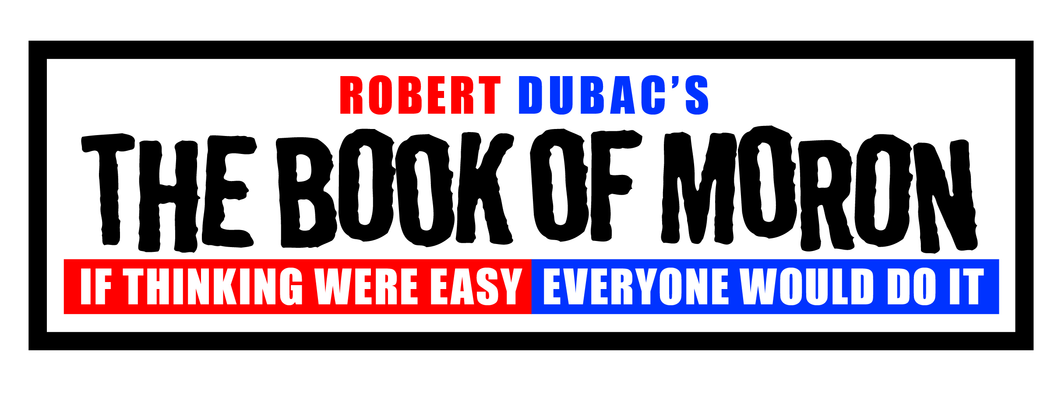
SHORT REVIEWS

THE DENVER POST

THE BOOK OF MORON is high-concept comedy that is provocative and smart, an erudite comic trek. Robert Dubac is a razor-sharp comedian and THE BOOK OF MORON is a terrific show, witty and incisive, clever and acute. 3.5 stars out of four!

HUFFINGTON POST

Dubac is a master of his craft. THE BOOK OF MORON is a show chock full of wonderful laughter, joyful surprises and unexpected applause-break moments. In THE BOOK OF MORON, Robert Dubac presents wisdom disguised as wit and high art in the guise of mass-appeal entertainment.

AURORA SENTINEL

You’ll laugh until it hurts. For almost 90 minutes in THE BOOK OF MORON Robert Dubac delivers a honed, astute and hilarious romp. He and the show are slick and fun. The Book of Moron is a hysterical and wise ride. Everyone walks away at with face fatigue from grinning like a fool and laughing like one, too.

PITTSBURGH-TRIBUNE REVIEW

THE BOOK OF MORON is Robert Dubac's very funny, sometimes outrageous examination of truth and illusion. His insights will likely challenge or infuriate nearly everyone at some point.

AUSTIN REPUBLIC

In THE BOOK OF MORON Robert Dubac is a straight talker who speaks in circles. He is an actor, a linguist, a magician and a comedian, yet he is not fully any of these things — and that's the beauty of it. He is not easy to define and, therefore, his ideas are not easy to dismiss. He catches you off balance, and before you either fall or catch yourself, you are able to open up and truly hear.

In this thought provoking solo performance Dubac is following in the footsteps of other social satirists, like George Carlin, in speaking the truth through his art. Where George Carlin is acerbic and vitriolic, however, this guy is a delicate, linguistic surgeon.

AUSTIN CULTURE MAP

Sitting in the dark, surrounded by strangers, I found myself laughing out loud. THE BOOK OF MORON is an engaging and thought provoking performance, delivered with biting wit. The good, the bad, the ridiculous.

In the age of 3-D movies and computer generated imagery, this one man performance is refreshing, hilarious, poignant and sure to delight. THE BOOK OF MORON is not to be missed!

THE ST. PETERSBURG TIMES

In THE BOOK OF MORON Dubac delivers a scorching hour of wry, pointed social commentary, from political satire to examinations of linguistic vagaries.

PHILADELPHIA-MONGTGOMERY NEWS

Dubac unleashes his full arsenal of talent in THE BOOK OF MORON. Dubac's humor is at once dizzying and poignant, providing laugh-out-loud humor for all of us along on his all-too-honest journey of self-discovery.

"Moron" is the thinking-man's one-man show. Yet the performance is surprisingly personal, as though he is speaking to you about you.

EXAMNINER.COM

Dubac's THE BOOK OF MORON is fast-paced, loaded with intelligent thought-provoking conundrums and witticism, and always a laugh a minute.

LITTLETON INDEPENDENT

Robert Dubac is a bit of a challenge to categorize, with lightning fast, funny delivery of satiric commentary on contemporary culture - that world which both sustains us and frustrates us daily. Is this how a 21st century Mark Twain might sound?

